2022/2023 Girls Weightlifting Schedule
*2021 Team State Runner Up*
Date Time Location VS.
11/2 4:30 Vernon Weightroom Vernon/Chipley
11/10 4:00 Marianna Weightroom Marianna/Chipley
11/16 3:30 Marianna Weightroom Marianna/Sneads
11/30 1:00 Altha Old Gym Marianna/BHS/Vernon/Sneads
12/7 2:00 Altha Weightroom Liberty County
1/13 9:00 Marianna Old Gym GVG 2023
1/25 9:00 Altha Old Gym District 3 Championships
2/4 11:00 Suwannee Gym Region Championships
2/16 2:15 Altha School State Qualifier Hall Walk
2/18 10:00 Lakeland State Championships

*All Times CST, Schedule subject to change.
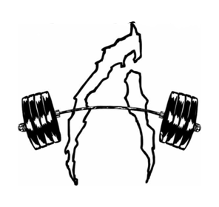
16 State Champions
53 State Medalists
2021 Team State Runner Up

